OS Important
1. What is an operating system?
An operating system is a program that acts as an intermediary between the user and the computer hardware. The purpose of an OS is to provide an environment in which user can execute programs in a convenient and efficient manner.
2. What are the different operating systems?
1. Batched operating systems
2. Multi-programmed operating systems
3. timesharing operating systems: Time-sharing is a technique which enables many people, located at various terminals, to use a particular computer system at the same time. Time-sharing or multitasking is a logical extension of multiprogramming. Processor's time which is shared among multiple users simultaneously is termed as time-sharing.
4. Distributed operating systems
5. Real-time operating systems
3. What are the basic functions of an operating system?
Operating system controls and coordinates the use of the hardware among the various applications programs for various uses. Operating system acts as resource allocator and manager. It is especially concerned with the operation and control of I/O devices.
4. What is kernel?
The kernel is a computer program that constitutes the central core of a computer's operating system. It is the first program loaded on startup, and then manages the remainder of the startup, as well as input/output requests from software, translating them into data processing instructions for the central processing unit. It is also responsible for managing memory, and for managing and communicating with computing peripherals, like printers, speakers, etc. The kernel is a fundamental part of a modern computer's operating system.
5. What is difference between micro kernel and macro kernel?
Micro kernel is a kernel which run services those are minimal for operating system performance. In this kernel all other operations are performed by processor.
Macro Kernel is a combination of micro and monolithic kernel. In monolithic kernel all operating system code is in single executable image.
6. What is dead lock?
Deadlock is a situation or condition where the two processes are waiting for each other to complete so that they can start. This result both the processes to hang.
7. What is a process?
A program in execution is called a process.
Processes are of two types:
1. Operating system processes
2. User processes
8. What are the states of a process?
1. New
2. Ready
3. Running
4. Waiting
5. Terminated
9. What is starvation and aging?
Starvation is Resource management problem where a process does not get the resources it needs for a long time because the resources are being allocated to other processes.
In Operating systems, Aging is a scheduling technique used to avoid starvation. Fixed priority scheduling is a scheduling discipline, in which tasks queued for utilizing a system resource are assigned a priority each. A task with a high priority is allowed to access a specific system resource before a task with a lower priority is allowed to do the same. A disadvantage of this approach is that tasks assigned with a lower priority may be starved when a large number of high priority tasks are queued. Aging is used to gradually increase the priority of a task, based on its waiting time in the ready queue.

10. What is semaphore?
Semaphore is a variable, whose status reports common resource, Semaphore is of two types one is Binary semaphore and other is Counting semaphore.
11. What is context switching?
Transferring the control from one process to other process requires saving the state of the old process and loading the saved state for new process. This task is known as context switching.
12. What is a thread?
A thread is a program line under execution. Thread sometimes called a light-weight process, is a basic unit of CPU utilization; it comprises a thread id, a program counter, a register set, and a stack
13. What is process synchronization?
A situation, where several processes access and manipulate the same data concurrently and the outcome of the execution depends on the particular order in which the access takes place, is called race condition. To guard against the race condition we need to ensure that only one process at a time can be manipulating the same data. The technique we use for this is called process synchronization.

14. What is Virtual Memory?
Virtual memory is hardware technique where the system appears to have more memory that it actually does. This can be done by time-sharing between the physical memory and storage parts of the memory on disk when they are not actively being used.
A computer can address more memory than the amount physically installed on the system. This extra memory is actually called virtual memory and it is a section of a hard disk that's set up to emulate the computer's RAM.
Modern microprocessors intended for general-purpose, use a memory management unit, or MMU, is built into the hardware. The MMU's job is to translate virtual addresses into physical addresses. A basic example is given below −
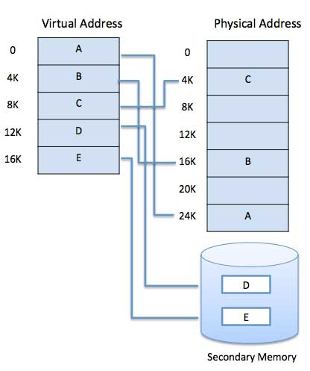

The main visible advantage of this scheme is:
- The gives the ability to execute a program that is only partially in memory.
- A program would no longer be constrained by the amount of physical memory that is available.
- Each user program could take less physical memory, more programs could be run the same time, with a corresponding increase in CPU utilization and throughput.
- It allows us to extend the use of physical memory by using disk.
- It allows us to have memory protection, because each virtual address is translated to a physical address.
Following are the situations, when entire program is not required to be loaded fully in main memory.
- Many times we want to execute a program such that it is only partially in memory. Example: movie files of big size.
- User written error handling routines are used only when an error occurred in the data or computation.
- Certain options and features of a program may be used rarely.
- Many tables are assigned a fixed amount of address space even though only a small amount of the table is actually used.
Virtual memory is commonly implemented by paging, demand paging, segmentation, demand segmentation, etc (discussed later).
What is Memory Management?
Memory management is the functionality of an operating system which handles or manages primary memory and moves processes back and forth between main memory and disk during execution. Memory management keeps track of each and every memory location, regardless of either it is allocated to some process or it is free. It checks how much memory is to be allocated to processes. It decides which process will get memory at what time. It tracks whenever some memory gets freed or unallocated and correspondingly it updates the status.
Process Address space: The process address space is the set of logical addresses that a process references in its code. For example, when 32-bit addressing is in use, addresses can range from 0 to 0x7fffffff; that is, 2^31 possible numbers, for a total theoretical size of 2 gigabytes.
The operating system takes care of mapping the logical addresses to physical addresses at the time of memory allocation to the program. The set of all logical addresses generated by a program is referred to as a logical address space. The set of all physical addresses corresponding to these logical addresses is referred to as a physical address space.
The runtime mapping from virtual to physical address is done by the memory management unit (MMU) which is a hardware device.
Swapping: Swapping is a mechanism in which a process can be swapped temporarily out of main memory (or move) to secondary storage (disk) and make that memory available to other processes. At some later time, the system swaps back the process from the secondary storage to main memory.
Though performance is usually affected by swapping process but it helps in running multiple and big processes in parallel and that's the reason Swapping is also known as a technique for memory compaction.
Memory allocation: Main memory usually has two partitions −
- Low Memory − Operating system resides in this memory.
- High Memory − User processes are held in high memory.
Paging: Paging technique plays an important role in implementing virtual memory. Paging is a memory management technique in which process address space is broken into blocks of the same size called pages (size is power of 2, between 512 bytes and 8192 bytes means 0.5 kb to 8 kb). The size of the process is measured in the number of pages.
Similarly, main memory is divided into small fixed-sized blocks of (physical) memory called frames and the size of a frame is kept the same as that of a page to have optimum utilization of the main memory and to avoid external fragmentation.
A data structure called page map table is used to keep track of the relation between a page of a process to a frame in physical memory.
When a process is to be executed, its corresponding pages are loaded into any available memory frames. Suppose you have a program of 8Kb but your memory can accommodate only 5Kb at a given point in time, then the paging concept will come into picture. When a computer runs out of RAM, the operating system (OS) will move idle or unwanted pages of memory to secondary memory to free up RAM for other processes and brings them back when needed by the program.
This process continues during the whole execution of the program where the OS keeps removing idle pages from the main memory and write them onto the secondary memory and bring them back when required by the program.
Advantages and disadvantages of paging −
- Paging reduces external fragmentation, but still suffer from internal fragmentation.
- Paging is simple to implement and assumed as an efficient memory management technique.
- Due to equal size of the pages and frames, swapping becomes very easy.
- Page table requires extra memory space, so may not be good for a system having small RAM.
Demand Paging: A demand paging system is quite similar to a paging system with swapping where processes reside in secondary memory and pages are loaded only on demand, not in advance. When a context switch occurs, the operating system does not copy any of the old program’s pages out to the disk or any of the new program’s pages into the main memory Instead, it just begins executing the new program after loading the first page and fetches that program’s pages as they are referenced.
Following are the advantages of Demand Paging −
- Large virtual memory.
- More efficient use of memory.
- There is no limit on degree of multiprogramming.
Following are the disadvantages of Demand Paging −
- Number of tables and the amount of processor overhead for handling page interrupts are greater than in the case of the simple paged management techniques.
Page Fault: A page fault is a type of interrupt, called trap, raised by computer hardware when a running program accesses a memory page that is mapped into the virtual address space, but not actually loaded into main memory.
Page Replacement Algorithm: Page replacement algorithms are the techniques using which an Operating System decides which memory pages to swap out, write to disk when a page of memory needs to be allocated. Paging happens whenever a page fault occurs and a free page cannot be used for allocation purpose accounting to reason that pages are not available or the number of free pages is lower than required pages.
When the page that was selected for replacement and was paged out, is referenced again, it has to read in from disk, and this requires for I/O completion. This process determines the quality of the page replacement algorithm: the lesser the time waiting for page-ins, the better is the algorithm.
Segmentation: Segmentation is a memory management technique in which each job is divided into several segments of different sizes, one for each module that contains pieces that perform related functions. Each segment is actually a different logical address space of the program.
When a process is to be executed, its corresponding segments are loaded into non-contiguous memory though every segment is loaded into a contiguous block of available memory.
Segmentation memory management works very similar to paging but here segments are of variable-length where as in paging pages are of fixed size.
A program segment contains the program's main function, utility functions, data structures, and so on. The operating system maintains a segment map table for every process and a list of free memory blocks along with segment numbers, their size and corresponding memory locations in main memory. For each segment, the table stores the starting address of the segment and the length of the segment.
Fragmentation: As processes are loaded and removed from memory, the free memory space is broken into little pieces. It happens after sometimes that processes cannot be allocated to memory blocks considering their small size and memory blocks remains unused. This problem is known as Fragmentation.
Fragmentation is of two types −
- External Fragmentation: Total memory space is enough to satisfy a request or to reside a process in it, but it is not contiguous, so it cannot be used.
The following diagram shows how fragmentation can cause waste of memory and a compaction technique can be used to create more free memory out of fragmented memory −
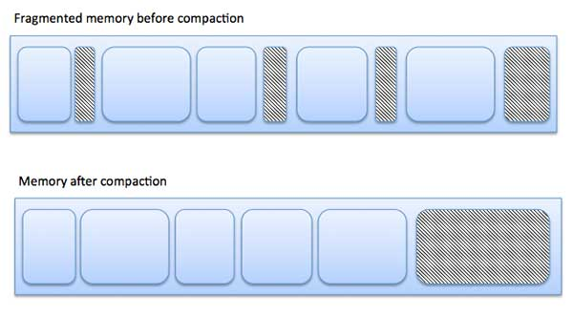
External fragmentation can be reduced by compaction or shuffle memory contents to place all free memory together in one large block. To make compaction feasible, relocation should be dynamic.
- Internal Fragmentation: Internal fragmentation occurs when memory allocation is based on fixed-size partitions(as in case of paging) where after a small size application is assigned to a slot the remaining free space of that slot is wasted.
Consider the following diagram which explains the internal fragmentation:
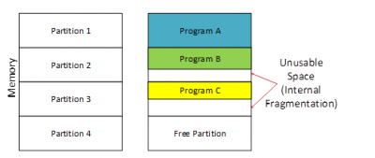

- The internal fragmentation can be reduced by appropriate page size in case of paging.

15. What is thrashing?
It is a phenomenon in virtual memory schemes when the processor spends most of its time swapping pages, rather than executing instructions. This is due to an inordinate number of page faults.

17. What are necessary conditions for dead lock?
1. Mutual exclusion (where at least one resource is non-sharable)
2. No preemption (where the resources can’t be preempted)
3. Hold and wait (where a process holds one resource and waits for other resource)
4. Circular wait (where p[i] is waiting for p[j] to release a resource. i= 1,2, n
j=if (i!=n) then i+1
else 1 )

18. What is cache memory?
Cache memory is random access memory (RAM) that a computer microprocessor can access more quickly than it can access regular RAM. As the microprocessor processes data, it looks first in the cache memory and if it finds the data there (from a previous reading of data), it does not have to do the more time-consuming reading of data from larger memory.

20. Differentiate between Complier and Interpreter?
An interpreter reads one instruction at a time and carries out the actions implied by that instruction. It does not perform any translation. But a compiler translates the entire instructions

21. What is Throughput, Turnaround time, waiting time and Response time?
Throughput  number of processes that complete their execution per time unit
Turnaround time  amount of time to execute a particular process
Waiting time  amount of time a process has been waiting in the ready queue
Response time  amount of time it takes from when a request was submitted until the first response is produced, not output (for time-sharing environment)

22. What is Memory-Management Unit (MMU)?
Hardware device that maps virtual to physical address. The user program deals with logical addresses; it never sees the real physical addresses.

23. What is a Real-Time System?
A real time process is a process that must respond to the events within a certain time period. A real time operating system is an operating system that can run real time processes successfully

24. What is a trap and trapdoor?
Trapdoor is a secret undocumented entry point into a program used to grant access without normal methods of access authentication. A trap is a software interrupt, usually the result of an error condition.

25. When is a system in safe state?
The set of dispatchable processes is in a safe state if there exists at least one temporal order in which all processes can be run to completion without resulting in a deadlock.

26. Explain the concept of the Distributed systems?
Distributed systems work in a network. They can share the network resources, communicate with each other.

27. What is cache-coherency?
In a multiprocessor system there exist several caches each may containing a copy of same variable A. Then a change in one cache should immediately be reflected in all other caches this process of maintaining the same value of a data in all the caches s called cache-coherency.

28. What is a long term scheduler & short term schedulers?
Long term schedulers are the job schedulers that select processes from the job queue and load them into memory for execution. The short term schedulers are the CPU schedulers that select a process from the ready queue and allocate the CPU to one of them.

29. Explain the meaning of mutex.
Mutex is the short form for Mutual Exclusion object. A mutex allows multiple threads for sharing the same resource. The resource can be file. A mutex with a unique name is created at the time of starting a program. A mutex must be locked from other threads, when any thread that needs the resource. When the data is no longer used / needed, the mutex is set to unlock.

